UML Diagrams

1. Use Cases.
2. Admin Login.

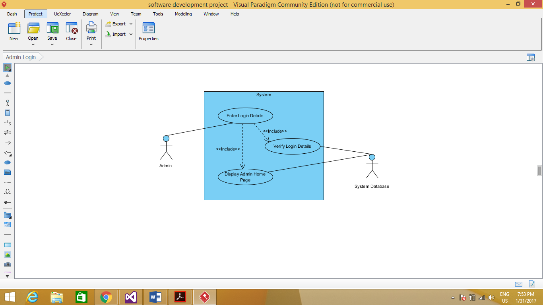

1. Admin Add Book Details into System’s Database.

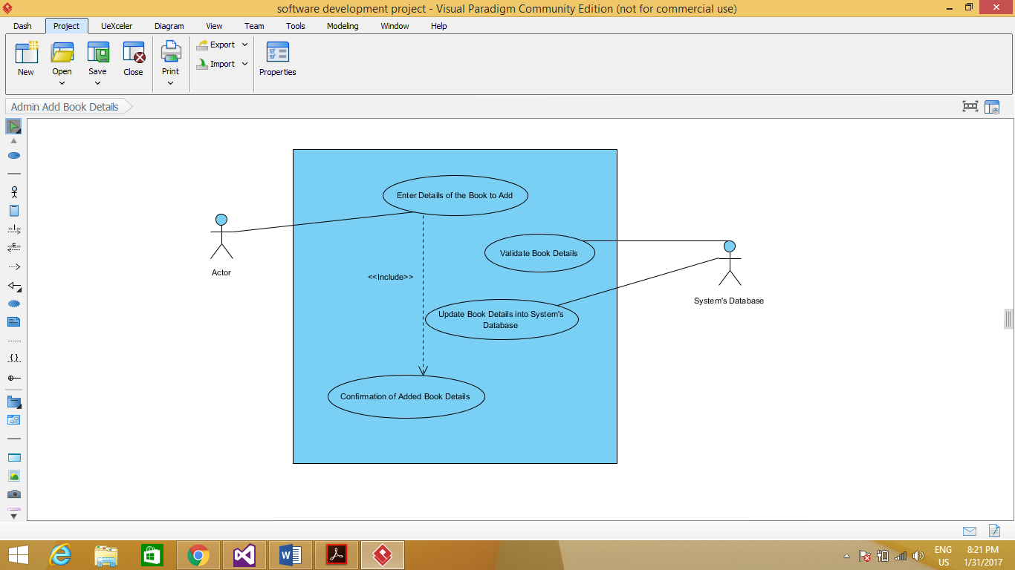

1. Admin Removes Book from System’s Database.

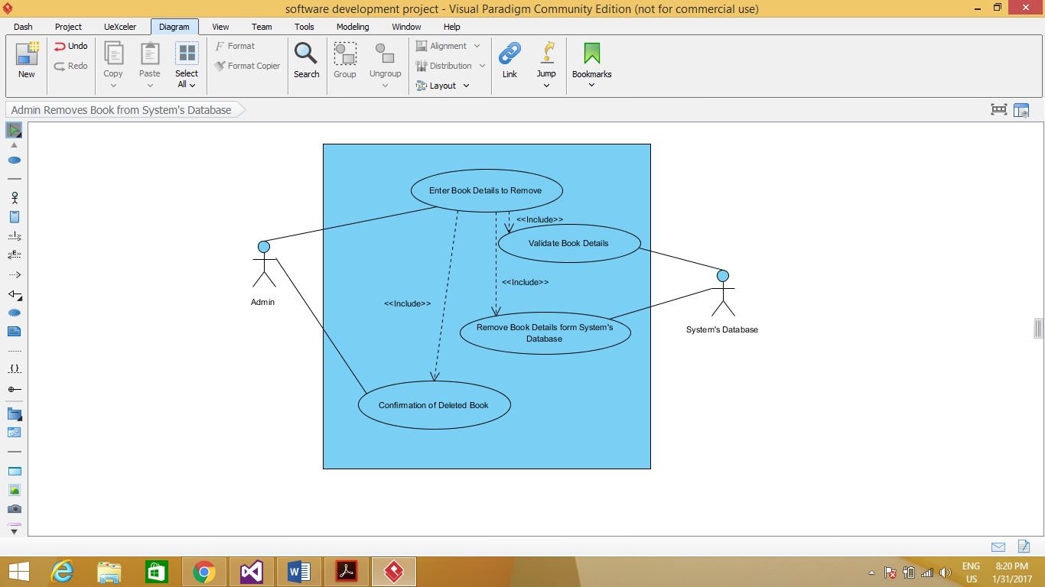

1. Admin Updates Book Details into System’s Database.

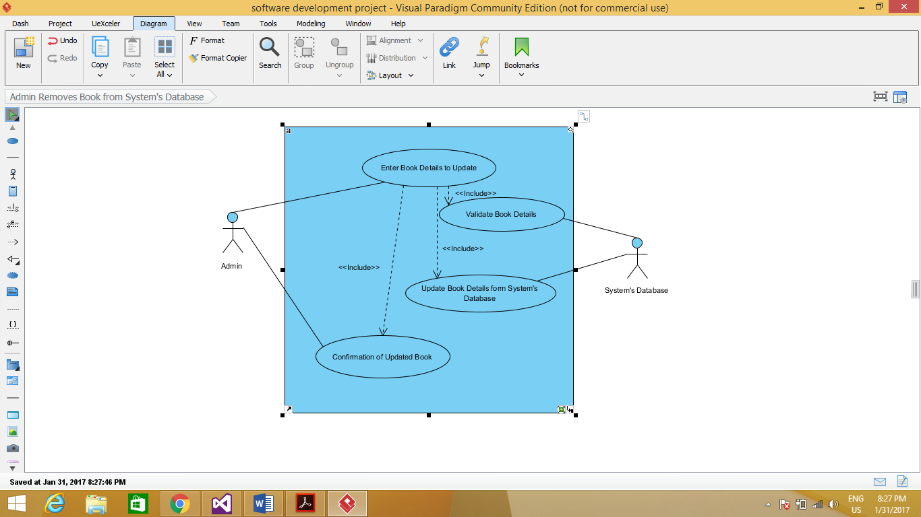

1. Customer/User Registers for a Login Account.

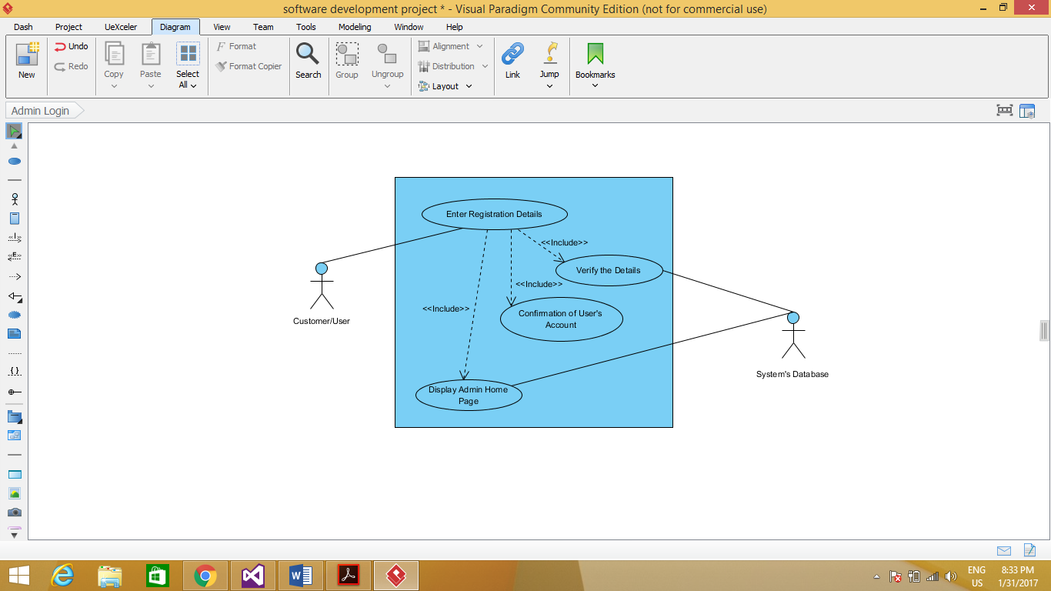

1. Customer/User Searches for a Book.

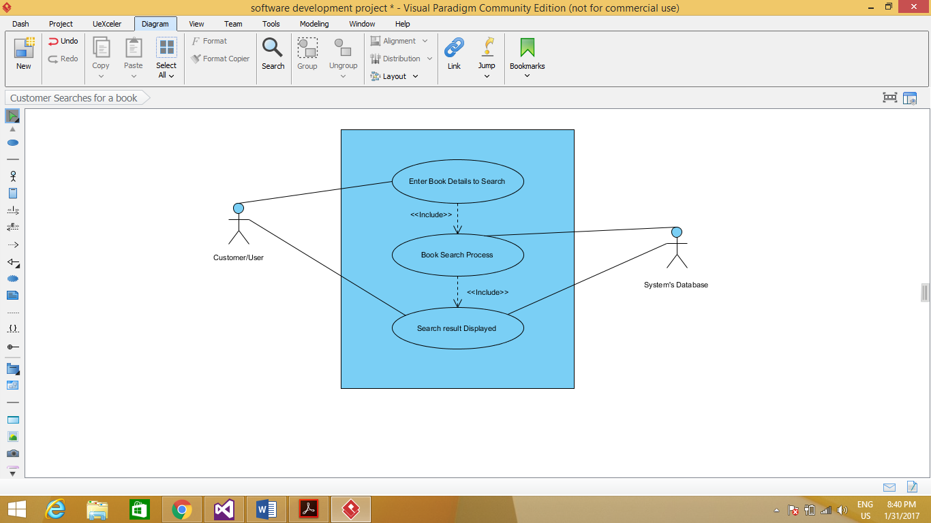

1. Customer/User Wishes to Preview any Book.

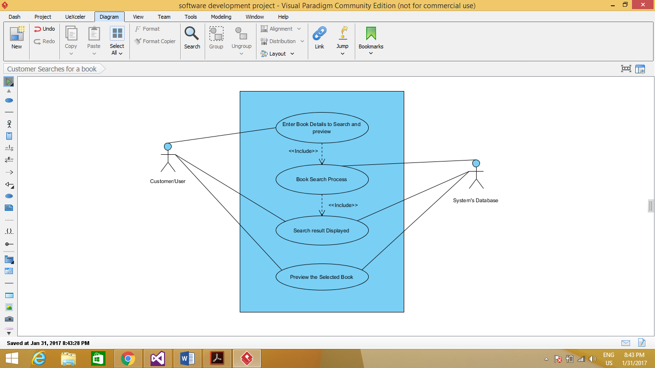

1. Customer/User Updating Account.

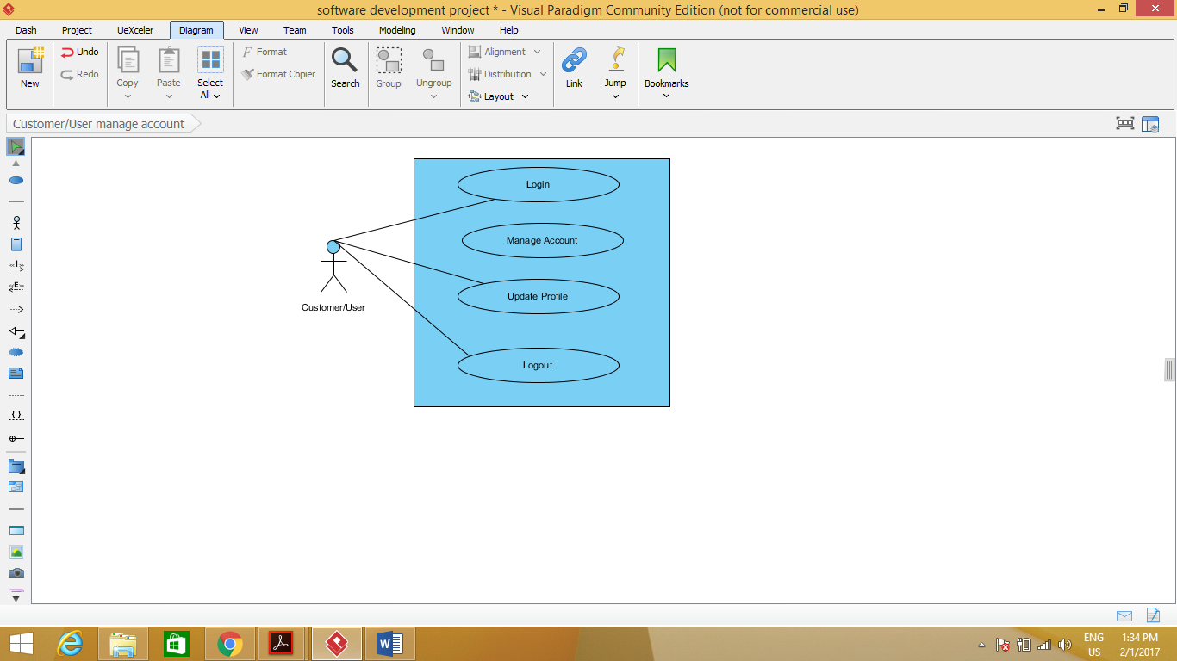

1. Customer/User Placing an Order & Checkout

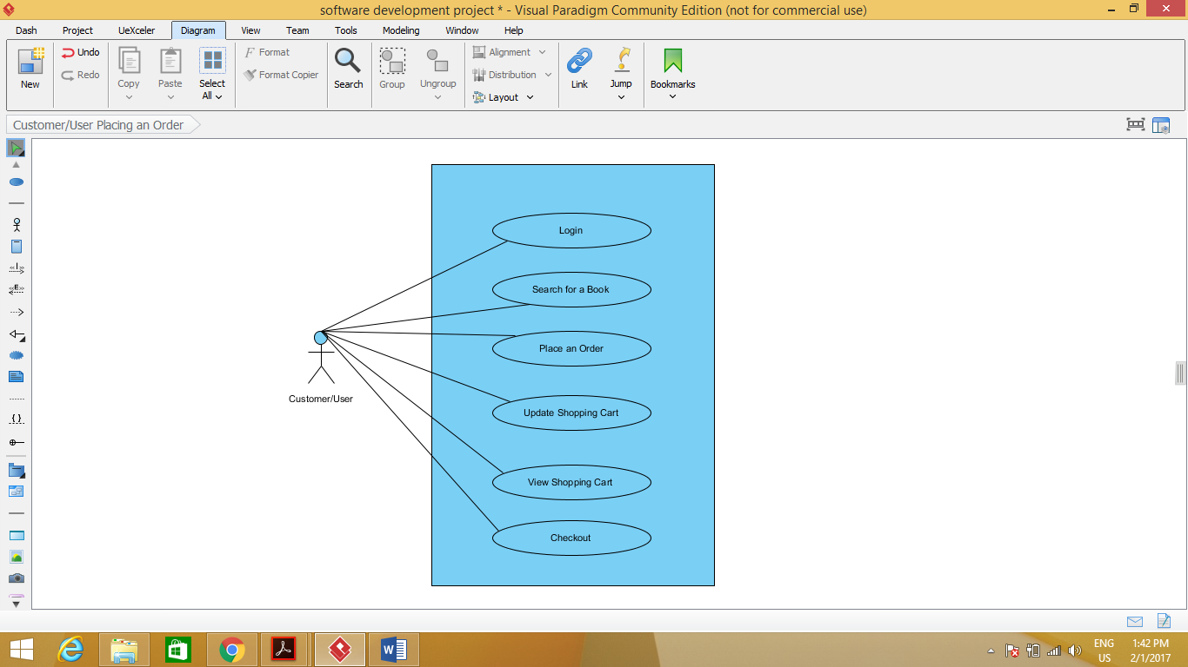

1. Flow Diagram- Customer/User.

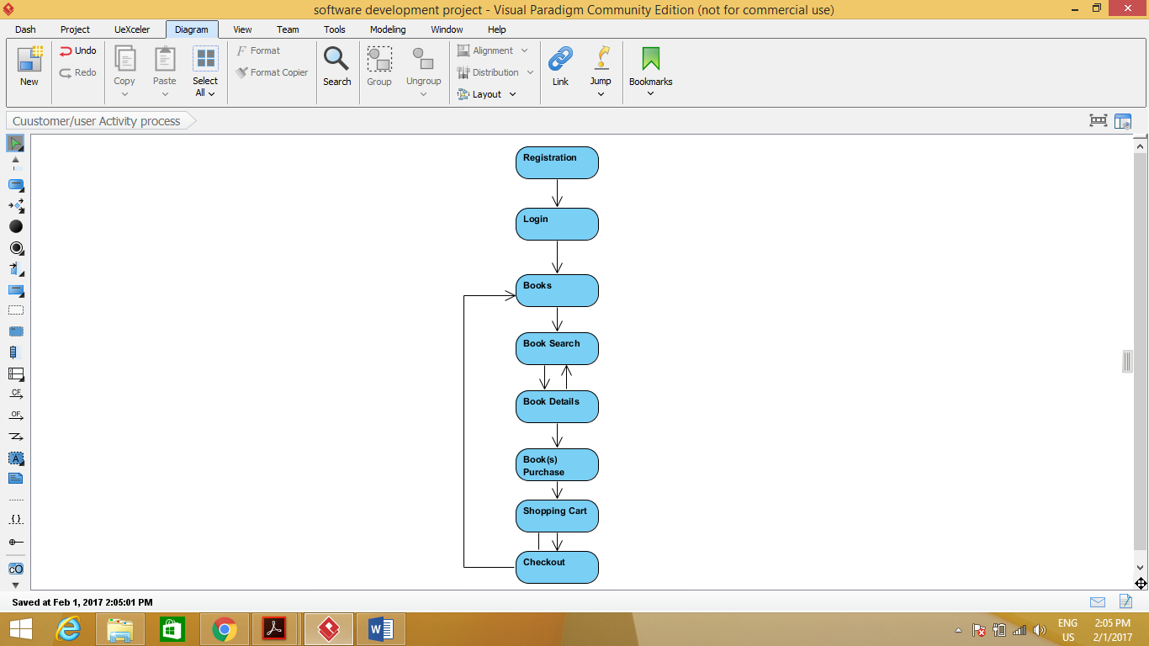

1. CRC Cards.
2. Books.

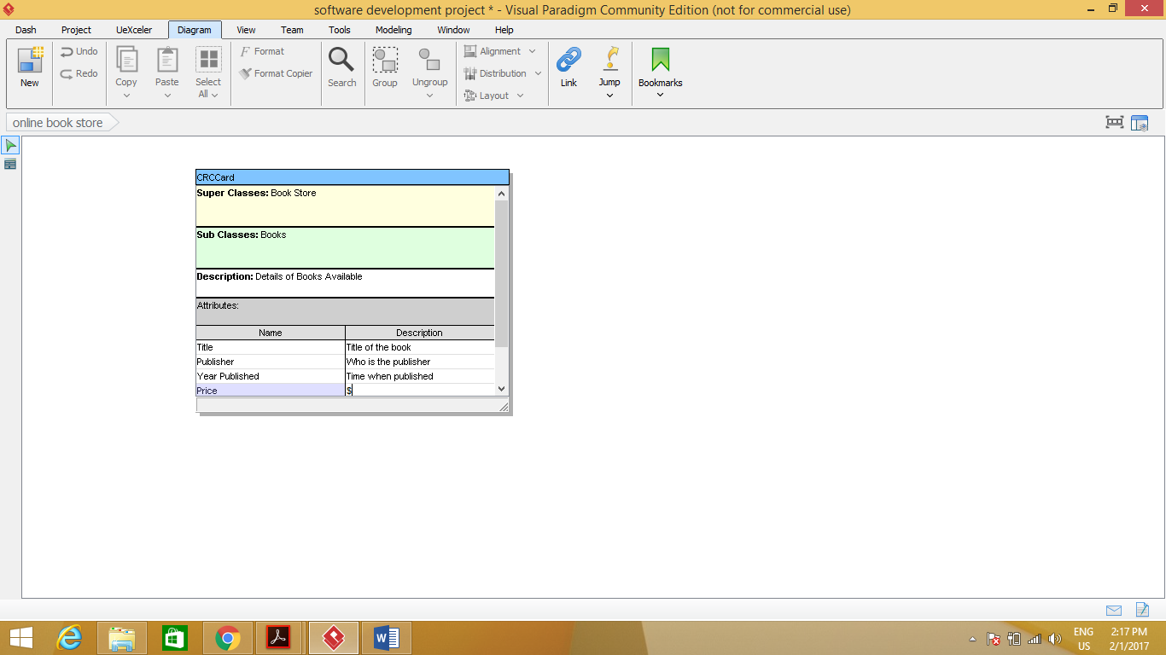

1. Books Ordered.

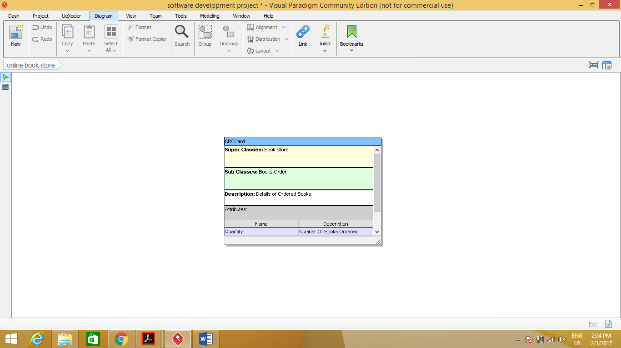

1. Customer/User

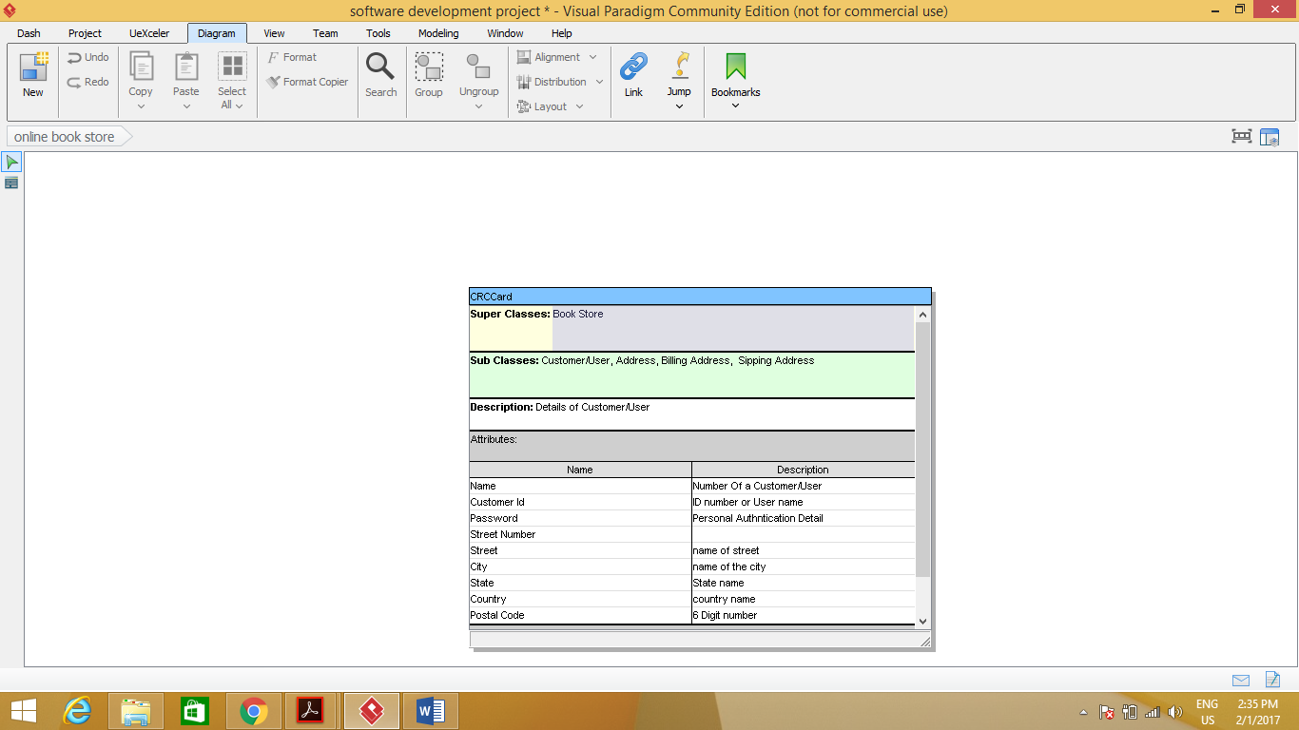

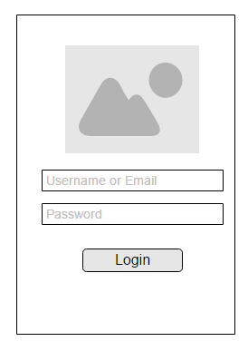**Paper Prototype**

